Recorder 6 developer setup

These notes describe how to install Recorder 6 on Windows 10 (Home or Professional Edition). The exact build should not matter though the current latest Fall Creators update was used in this instance.

# Licence summary

Full details of licences required and installation are given throughout the notes – the following table summarises the costs and licence requirements in one place for convenience.

|  |  |  |
| --- | --- | --- |
| Product | Cost (Jan 2018) | Links and notes |
| Delphi 7 Professional | £1,390.80 | Purchase any Delph Professional Licence from <https://www.embarcadero.com/app-development-tools-store/delphi> and request a Delphi 7 download and licence from Embarcadero. |
| Korzh Localizer | $249 | Pro licence from <https://korzh.com/localizer/purchase>. |
| SMImport and SMExport | £87.84 | Combined bundle from <http://www.scalabium.com/sme>. |
| QuickReports | £358.80 | Pro 1 developer licence from <http://www.qbssoftware.com/products/Quickreport/licensing/_prodQUICKREP>. This includes the QRDesign component which is used by Recorder. |
| RapidTree | N/A | IMCA Systems seem to no longer exist, so licence cannot be purchased. This does not prevent Recorder 6 from being built though. |
| HTML Viewer Components | N/A | Now in the public domain – see <http://pbear.com/htmlviewers.html>, so no licence purchase required. |
| Fast Strings by Peter Morris | N/A | This product is freeware – see <http://www.delphipages.com/comp/fast_strings-5279.html>. |
| Shape Viewer Objects GIS from Ecological Software Solutions | N/A | No licence required as acknowledged in About box – as per instructions in *.pas file headers. |
| XPMenus from Khaled Shagrouni | N/A | No restrictions on use – see <http://cc.embarcadero.com/item/16253>. |
| VCLZip | $120 | Purchase a “One developer 1 year non-subscription” licence from <http://vclzip.bizland.com/html/buy_it.html>. Although this is only for 1 year, the period defined is for upgrades and the page states that the software continues to work afterwards. |
| MadExcept | 159 € | Purchase a commercial licence from <http://madshi.net/madExceptShop.htm>. As ongoing support and upgrades are not required there is no need to purchase a subscription or ongoing support. |
| MapServer 5 Turbo and MapUser |  | *Unsure if Graticule are still in existance.* Graticule MapServer 5 Turbo and associated MapUser licences required. Although Graticule appear to still exist according to Companies House (Geosoft Ltd), their website does not appear to have been updated since 2015 and I have not had a response to requests sent to [support@gratcule.com](mailto:support@gratcule.com) or an answer to their contact phone number. |

# Install SQL Server and Recorder 6

Before setting up your developer tools for Recorder 6, ensure you have a standalone installation of Recorder 6 to develop against. This should have a database exclusively for your own use rather than sharing a live database with other Recorder 6 users, allowing you to safely experiment with any changes you wish to make during development. If you don't have an available Site ID for development purposes you can use 4580 with a verification key of 4580. Installation notes and links to guides are available at http://www.recorder6.info/page13.html. Using the Express edition of SQL Server 2016 (http://www.microsoft.com/en-us/download/details.aspx?id=54284) is free and enough for basic development, but the Developer editing provides additional tools you may find useful. Either way you are likely to want to use SQL Server Management Studio during development so install that as well. Although we are using the 2016 release of SQL Server Express, this is only because Recorder 6 has not currently been tested on later versions. Using the latest release of SQL Server Management Studio (currently 2017.4) should not cause any problems though.

# Install Delphi 7 Professional

You will need to obtain a licence for Delphi 7 Professional. The resellers for Delphi in the UK are Embarcadero and, although you can no longer buy Delphi 7 directly, you can buy the latest version (currently 10.2 Tokyo) and contact Embarcadero who will be able to provide a Delphi 7 licence key. See <https://www.embarcadero.com/products/delphi/previous-versions> for more information. You need to purchase the Professional version licence or higher. Embarcadero will provide you with the required download files, plus a serial number and authorisation key which you will require during the install.

If Delphi 7 is provided as a zip archive, unzip the file to a temporary location on your hard disk, or just copy the files to a temporary folder. Run the install application file and select Yes to allow the installation procedure to make changes to your device. On the following options screen, choose the Delphi 7 option to begin the installation:

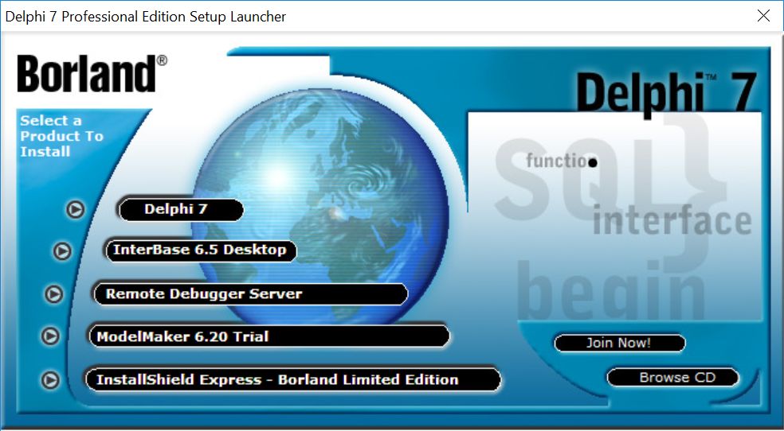

On the next Welcome page, click Next:

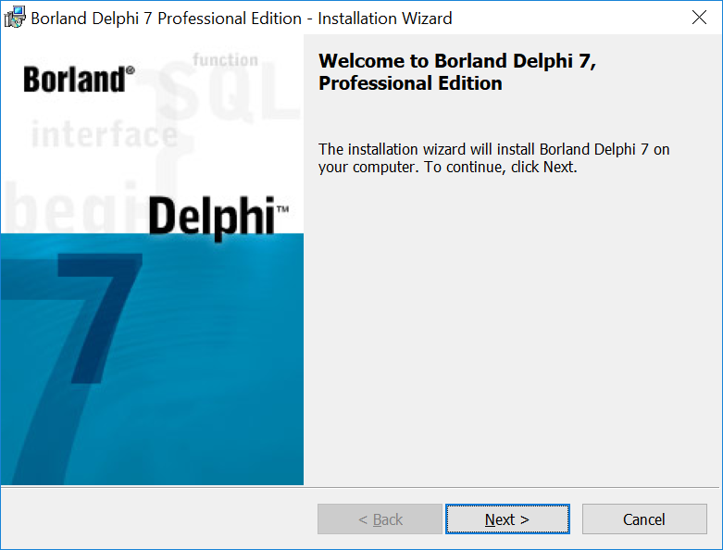

On the Serial Number page, enter the serial number and authorisation key provided by Embarcadero into the boxes and click Next:

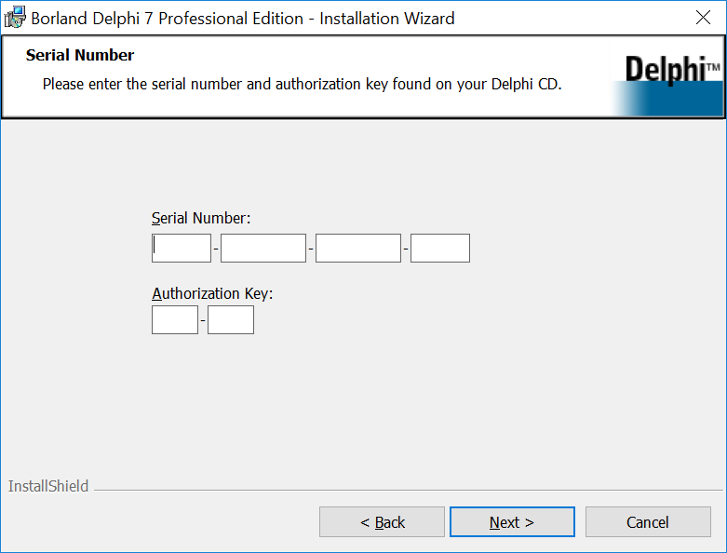

On the License Agreement page, select the “I accept...” option and click Next:

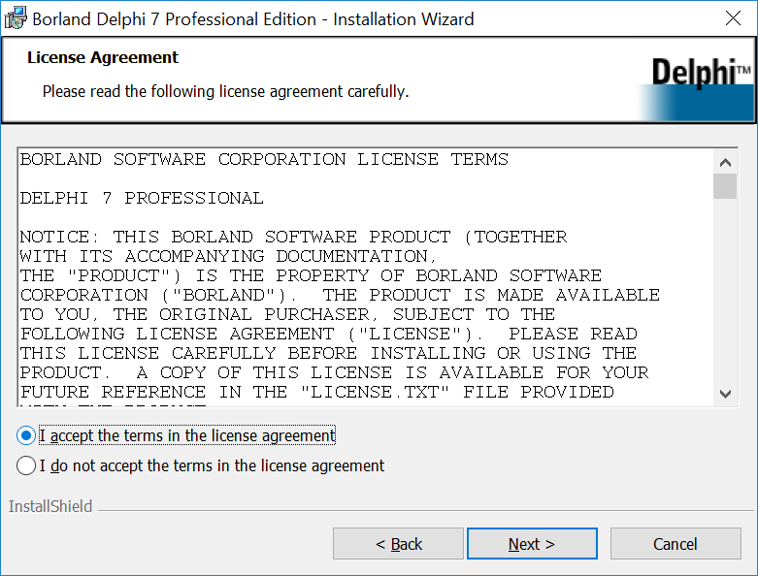

Click Next on the “Importand Installation Information” page, then on the Setup Type page choose the Custom option and click Next:

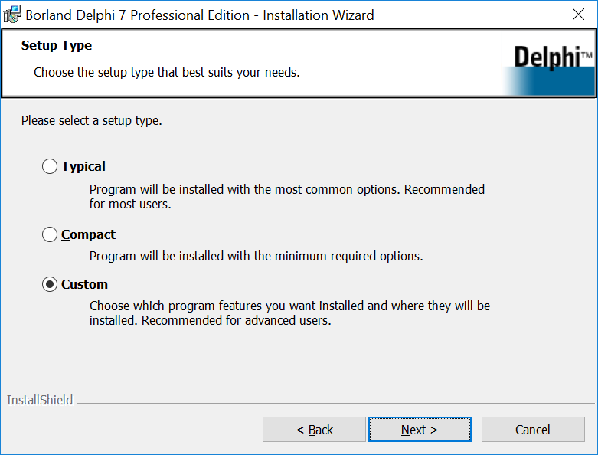

On the Custom Setup page, find the following entries in the hieararchy of components, then right click their icon and set their option to “Do not install”:

* Database Desktop
* Intraweb
* Rave Visual Designer

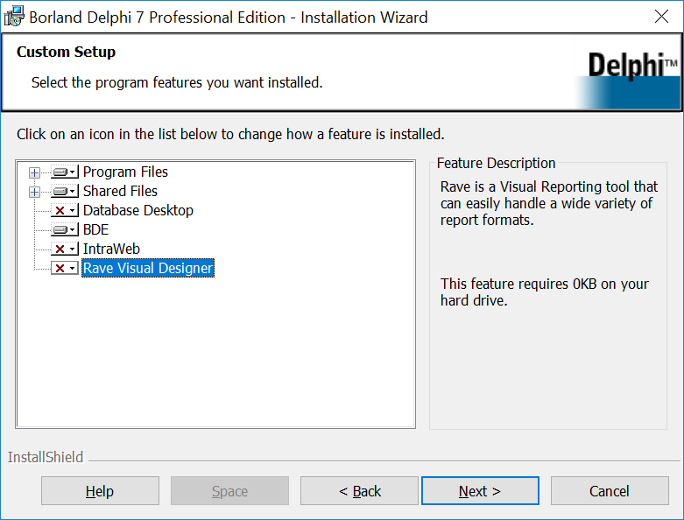

On the “Microsoft Office Controls” page, leave the default option “Office XP” selected and click Next:

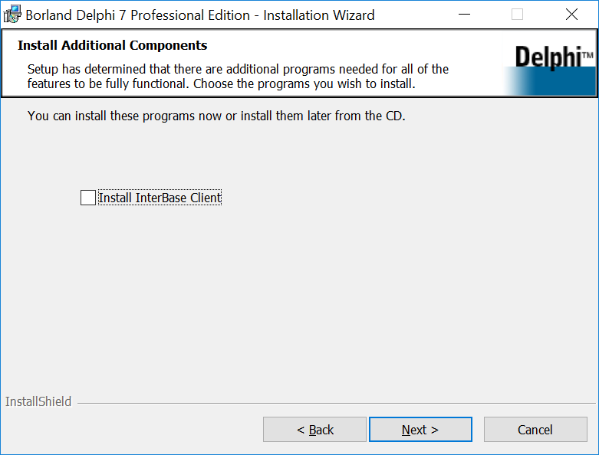

On the “Install Additional Components” page, untick the option to install the Interbase client and click Next:

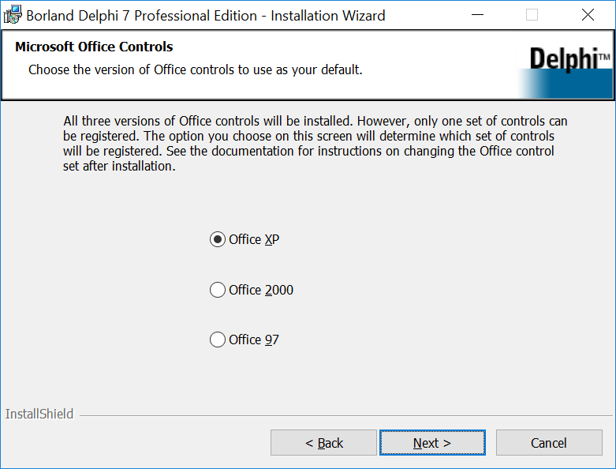

On the “Destination Folder” page, leave the destination folders at their default settings unless you have good reason to change them and click Next:

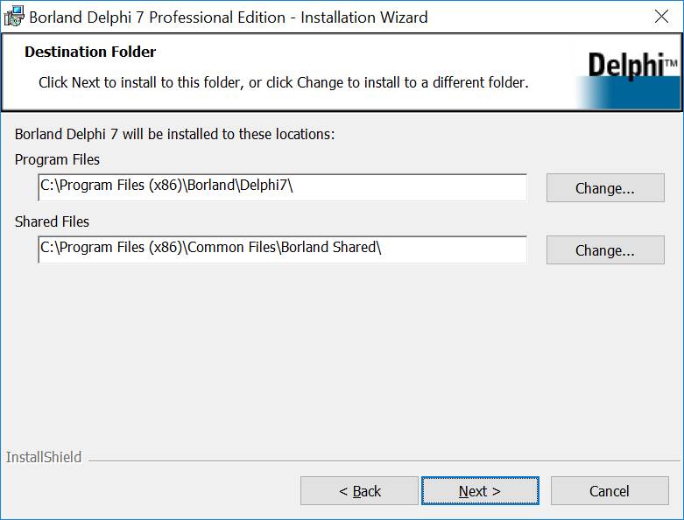

On the “Save Installation Database” page, ensure the option to save the installation database to the hard drive is ticked, then click Next:

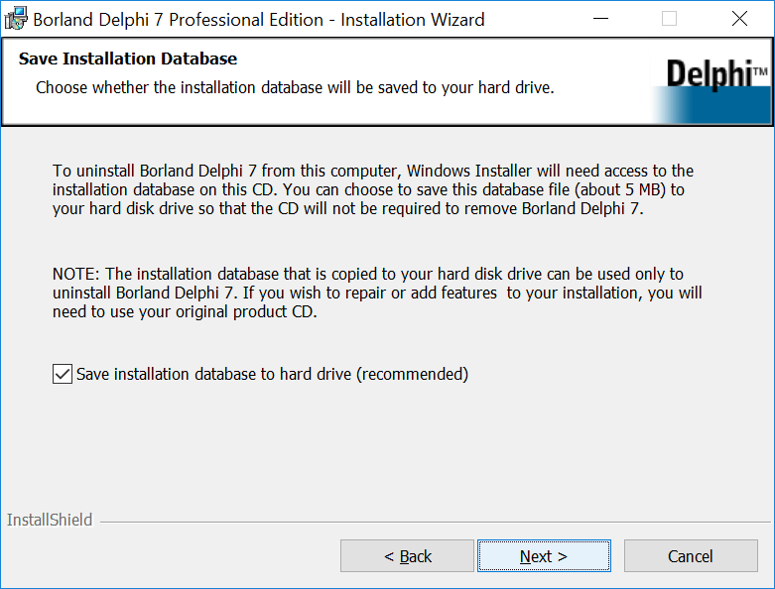

Then click the Install button to begin the installation process. When the installation completes, click Finish to close the installer then also close the Setup Launcher application.

If you were provided with Update 1 of Delphi 7 by Embarcadero, then your installation should be ready. In my case the Delphi 7 files available to me were for the original version of Delphi 7 so I needed to apply the Update 1 patch. Request a file called d7_pro_upd1_1.exe from Embarcadero or this file can be obtained from the Recorder 6 support team. Run this application and select Yes to allow the installation procedure to make changes to your device. Click Update on the “Welcome” page:

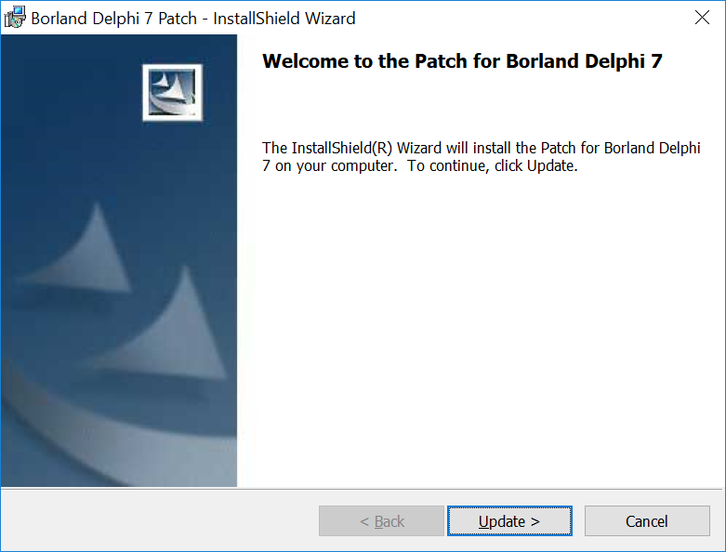

Click Finish when the patch installer completes.

You can now run the Delphi 7 application which should be available on your Start menu. The registration prompt will appear the first time you run Delphi:

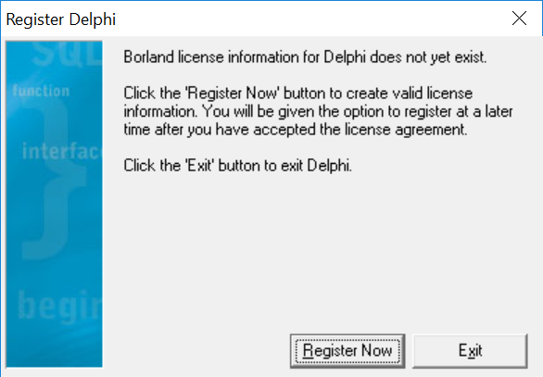

Click Register Now, then click check your licence details are entered correctly and click Next. Choose the option to accept the terms and conditions, click Next. On the “Borland Software Registration Wizard” page, choose the option to register using your internet connection then click Next.

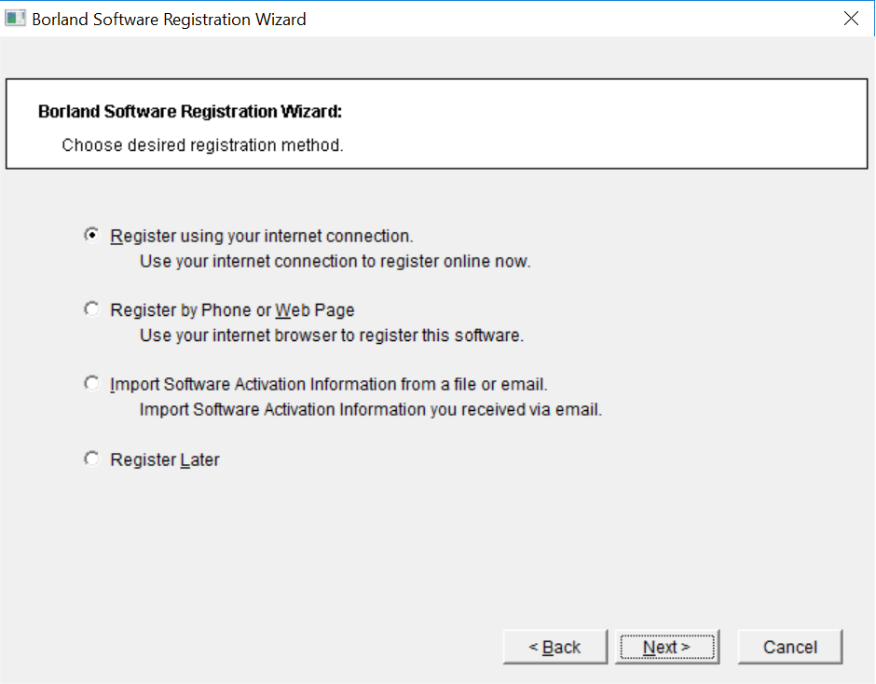

Now, follow through the registration wizard either using an existing Borland Community Account if you have one, or create a new one, until you have successfully registered the software. If asked whether you want to use an internet proxy during this process then leaving the option unchecked will work in the majority of cases. Click Finish when done.

*At this point Delphi 7 will start but is likely to show some errors relating to being unable to rename files. Click to close the errors, then close Delphi 7. Find Delphi 7 in your Start Menu again and this time, right click, choose “Run as administrator” to allow the installation process to complete properly. You only need to do this the first time Delphi 7 is run – the errors should no longer occur once it has been run once using the Run as administrator option.*

When starting Delphi 7, you may be asked about switching the Just-in-Time Debugger to the one provided with Delphi. There is no need to do this for the purposes of Recorder 6 development so click No and check “Don’t ask me this again” when you see this dialog.

## Blurry display issues

If you find that Delphi 7’s fonts appear generally blurry on a HD display running Windows 10, then you can try disabling the high DPI scaling which Windows 10 applies to applications under compatibility mode. Right click the icon in the Start Menu, then select “Open file location”. Now right click the Delphi 7 shortcut in the Explorer window which appears and choose the “Properties” menu item. On the Compatibility tab, tick the “Override high DPI scaling behaviour” checkbox and ensure that the scaling is performed by the application. Be careful when using this mode as you need to be aware that forms designed within an unscaled Delphi 7 will be scaled when viewed by the user, so they will appear small in the form designer compared to the compiled application.

# Getting the source code for Recorder 6

If you are new to version control and in particular Git, you might like to read a primer such as the Beginner section at https://www.atlassian.com/git/tutorials. Recorder 6 code is hosted on GitHub at https://github.com/recorder-6-team/recorder-6. To obtain the Recorder 6 source code, you will need a Git client, a tool which allows you to retrieve the latest copy of the code, switch between different branches of the code and manage your own changes and push them back up to the server. There are lots of different Git clients so feel free to use your favourite if you are already a Git user, if not then the Windows GitHub desktop client (<https://desktop.github.com>) is as good a place to start as any. I'll assume you are using the GitHub desktop client for these instructions, or that if you are using your own preferred client you know enough about Git to be able to translate these instructions to your own preferred tool's approach.

After installing the GitHub Desktop, you will need to sign into GitHub, creating a new account first if you don't already have one. The GitHub desktop will then start with 3 options available - create a new repository, add a local repository or clone a repository. Select the Clone a repository option:

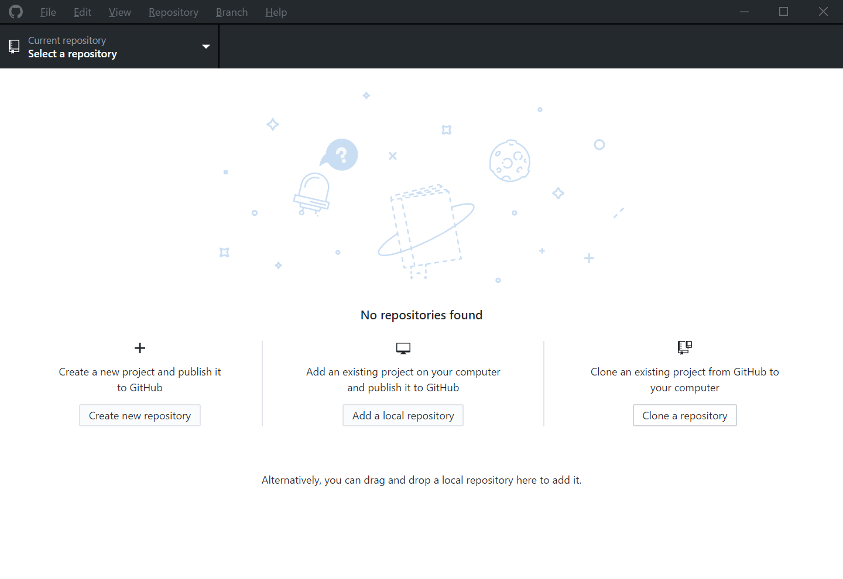

On the Clone a repository dialog, select the option to enter a URL and enter "https://github.com/jncc/recorder-6.git" (this URL can be found on the project GitHub home page at https://github.com/jncc/recorder-6 under the Clone or download button). Set the local path where the repository will be cloned to C:\localsource\recorder-6 and click Clone:

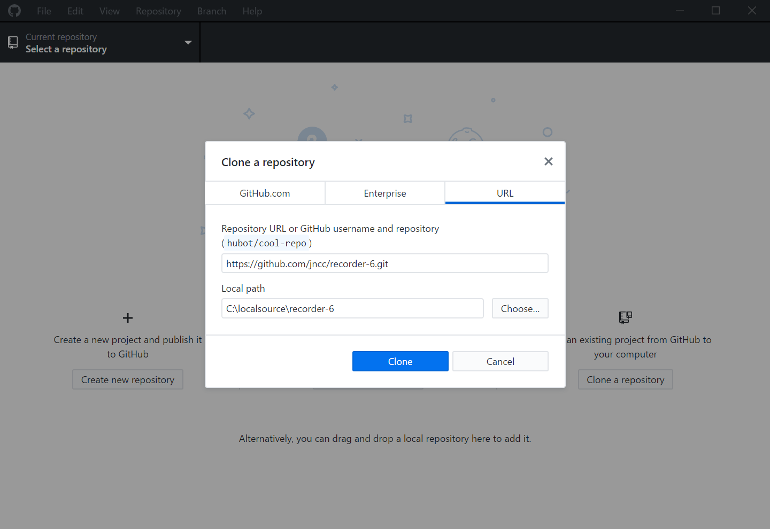

Note that although in theory you can clone the repository to any location on your local disk, using c:\localsource as a destination ensures that paths shared with other developers will be consistent, preventing possible problems further down the line.

## A note about branches

One of the features of Git is that it makes it easy to use multiple branches of the source code. For Recorder 6 there are always at least 2 branches of code:

* master - this is the code used for the current latest stable build of Recorder 6. Nothing is merged into this branch unless the code is ready to be released.
* develop – this is the current branch that is being developed. When ready for release it is merged into master.

For more advanced information on the way branches should be used please see the Gitflow Workflow (<https://www.atlassian.com/git/tutorials/comparing-workflows/gitflow-workflow>).

Since we are going to be developing, use the Current branch drop down at the top of your GitHub Desktop to select origin/develop.

# Third party components

## Third party source code

There are a number of third party components required for Recorder 6 which cannot be added to GitHub as that would violate the licence. Obtain the Third Party.zip file from the Recorder 6 support team and unzip it, merging into c:\localsource\recorder-6\Third Party.

# Component installation

## Korzh Localiser

Pro licence is required from <https://korzh.com/localizer/purchase>. Close Delphi 7 if it is running and run the locpro_setup_*.exe file provided (locpro_setup_04_05_00 is the version used for the live build if available) and follow the steps to install into the default location of c:\klib. On the Select Components page, untick all the options except Localizer Pro for Delphi 7, Language Manager and the compulsory KProcs Library:

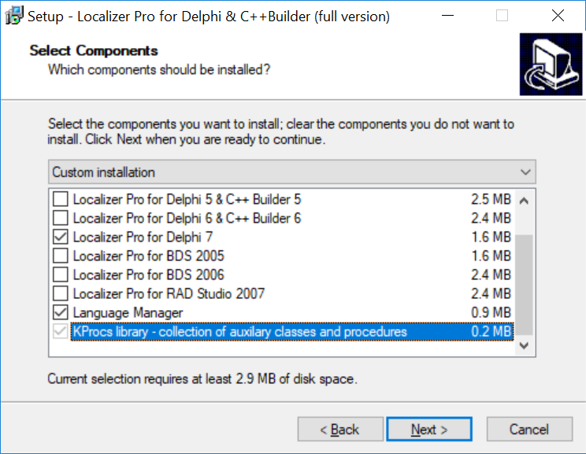

After installation, you should run the Localizer.key file provided with your purchase in order to store the licence information in the system registry. Run Delphi 7 then select Localizer > Help > About... from the menu to check that your copy has registered successfully.

## SMImport and SMExport

The A licence for the Scalabium SMImport and SMExport components can be purchased via the links for the combined bundle at <http://www.scalabium.com/sme/>. Once you have purchased the licence there is no actual installation required as the source code is provided along with other third party components as described earler.

## Quick Reports

Purchase a Pro 1 Developer Licence from <http://www.qbssoftware.com/products/Quickreport/licensing/_prodQUICKREP>. Instructions for installing the required packages into the Delphi IDE are provided in the section “Installing packages into Delphi 7”.

## MadExcept

The advanced exception handling tool used in Recorder 6 can be purchased from <http://madshi.net/madExceptShop.htm>. You will need to install version 3.0n which can be obtained from the Recorder 6 team. Ensure Delphi 7 is closed then copy the madshi.key file provided with your licence to the same location as the installation application. Run the madCollection.exe file and click Yes to allow the installer to make changes. On the list of installation options, toggle the options so that only madBasaic and madExcept 3 are selected:

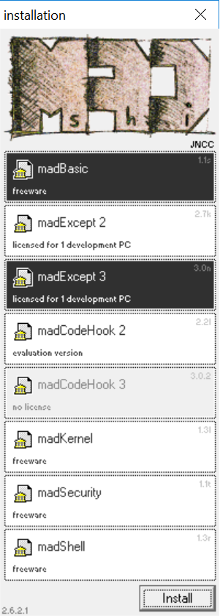

Click Install, then check the Accept licence box on the license agreement page, then click Continue.

On the following dialog, click Install to accept the default location. You should see the following message confirming installation was successful:

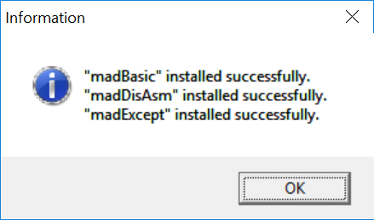

# Installing packages into Delphi 7

You will need to install a number of component packages into Delphi 7, both for third party components and bespoke ones written for Recorder 6 specifically. To do each one:

1. Start Delphi 7 if not already running.
2. Select Component > Install Packages... from the menu.
3. Click the Add button on the dialog which appears.

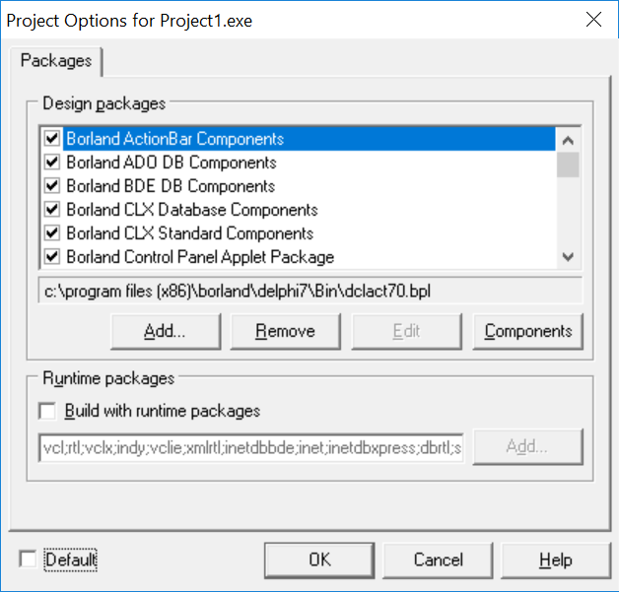

1. Browse to the file, select it and click Open.
2. Repeat steps 3 and 4 for each additional package.

The list of packages you need to install follows:

* C:\localsource\recorder-6\Compiled packages\InHouse7.bpl
* C:\localsource\recorder-6\Compiled packages\InHouse7_Design.bpl
* C:\localsource\recorder-6\Compiled packages\InHouseAPI7.bpl
* C:\localsource\recorder-6\Compiled packages\InHouseDB7.bpl
* C:\localsource\recorder-6\Compiled packages\RecorderAddin7.bpl
* C:\localsource\recorder-6\Compiled packages\UnitLib7.bpl
* C:\localsource\recorder-6\Third Party\Compiled Packages\Qrpt7.bpl
* C:\localsource\recorder-6\Third Party\Compiled Packages\Qrd7.bpl
* C:\localsource\recorder-6\Compiled packages\JnccQRDesign7.bpl
* C:\localsource\recorder-6\Third Party\IMCA Systems\Rapid Tree\Delphi7\rapid.bpl
* C:\localsource\recorder-6\Third Party\IMCA Systems\Rapid Tree\Delphi7\trecold7.bpl
* C:\localsource\recorder-6\Third Party\IMCA Systems\Rapid Tree\Delphi7\trecold7.bpl
* C:\Localsource\recorder-6\Third Party\L David Baldwin\HTML Components\Package\FrameViewer7.bpl
* C:\Localsource\recorder-6\Compiled packages\Extended3rdParty7.bpl
* C:\Localsource\recorder-6\Compiled packages\Jncc7.bpl*

Note that the Korzh Localizer package should be installed automatically when you installed the product earlier.

Also, after installing the packages it is worth closing Delphi 7 then reopening it. If Delphi 7 has any problems loading the packages it will warn you when it starts – it is quite common that Delphi will complain that it cannot load packages even though the paths are correct. If this happens, make sure you do not choose the option to remove the apparently missing packages for each message that appears, then open the Components > Install Packages... window again. Check the packages are present and checked, close the dialog, close Delphi 7 and run Delphi 7 again. Repeat this until the packages load OK (it took 2 attempts in my case).

# Building executables

Although it’s generally good practice to run applications on Windows as a normal user, it can sometimes be necessary to run Delphi 7 as an administrator since it was written before User Account Control was developed for Windows. For example, when building or changing addins Delphi 7 will attempt to re-register the type library file and can give a compile time RLINK32 error if it does not have the required permissions. If you see this, or other unexpected compiler errors, then closing Delphi 7 and running as administrator is worth trying.

## RecorderApp.exe

Follow these steps to prepare to build the Recorder application:

1. In Delphi 7, select File > Open Project... from the menu, then browse to c:\localsource\recorder-6\RecorderApp and open the RecorderApp.dpr file.
2. Create a new folder, c:\localsource\dcu where the interim compilation files will be placed.
3. Select Tools > Environment Options, then tick Show compiler progress on the Preferences tab and click OK.
4. To prevent Delphi stopping the debugger everytime Recorder 6 checks for the presence of an addin implementing an interface, select Tools -> Debugger Options, then on the Language Exceptions tab click Add. Enter EintfCastError in the Exception Type box, click Ok, then Ok again to save the changes.
5. Since the Recorder application is built under c:\Program Files (x86) which is a protected area, you need to change the file permissions. Using Windows Explorer, browse to find c:\Program Files (x86)\Recorder 6 and right click on the Recorder 6 folder then select Properties. On the Security tab, click Edit. Select the “Users” entry in the list, then check Allow for the Full control option – this will force the other checkboxes to also enable. Click Ok twice to save the changes.
6. Select Tools > Environment Options on the menu then select the Library tab. Click the ... button next to the Library paths input box.

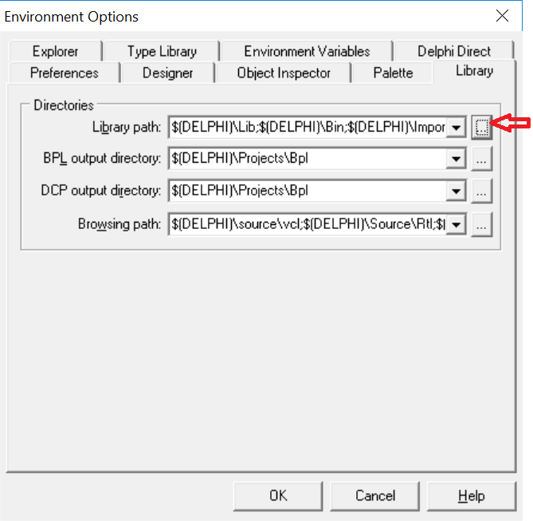

1. Enter the following path into the text box under the list of paths: “c:\localsource\recorder-6\AecorderApp\components”.

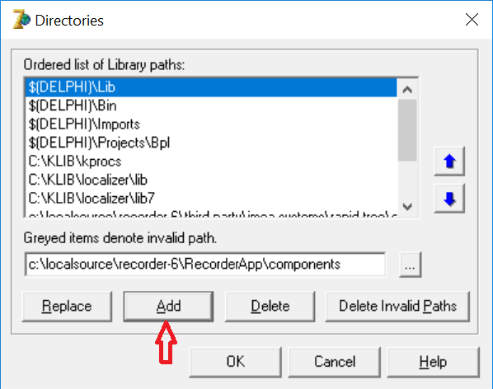

1. Click Add, then OK on both dialogs to accept the change.
2. Select Localizer > Project Settings... from the menu. Check the Localization Enabled checkbox and ensure your settings are as follows.

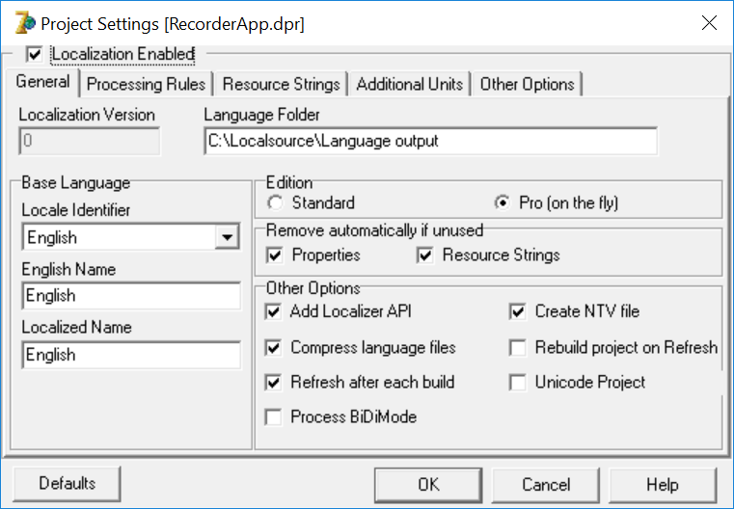

When you click OK on this dialog, Recorder will build so that Localizer can generate language files. It will then ask you if you want to add new languages – you can click No at this point.

Now, to build a new Recorder executable file select Project > Build RecorderApp from the menu. Click F9 to run the application under the Delphi debugger, which will also rebuild any changed files since the last full build. If you are releasing a built copy of the RecorderApp.exe, make sure you also supply the language files C:\localsource\Language output\RecorderApp.NTV and RecorderApp.ntv.lng and place them in the same folder as the executable.

## Compiler options

Although Delphi 7 includes a compiler option to optimise code generation (under Project > Project Options, Compiler tab), this option no longer works with the Recorder 6 source code and results in an internal error during compilation. The correct compiler and linked options are shown in the following 2 screenshots. Note that madExcept forces the including of certain debug and linking information in order to generate useful error reports.

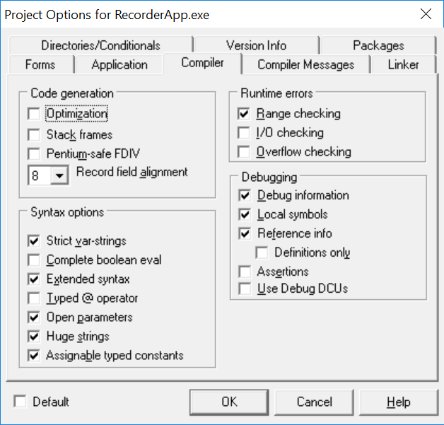

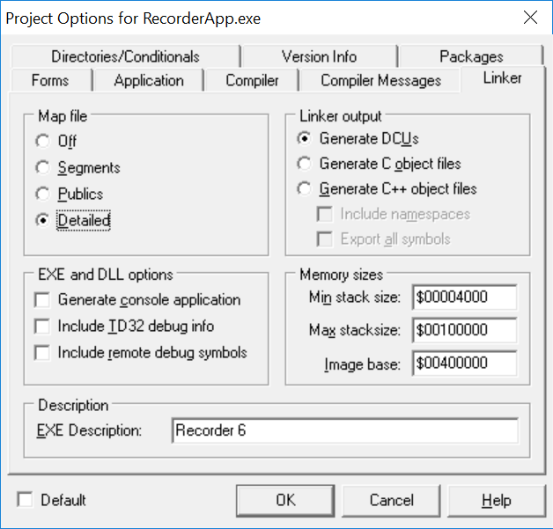

## Addins

Various *.dpr files for the addin projects can be found under c:\localsource\recorder-6\RecorderApp\Add-ins, c:\localsource\recorder-6\LC Addins and c:\localsource\recorder-6\SGB Addins. Check the following settings before compiling:

* Project > Options... dialog, Directories/Conditionals tab. Set Output directory to c:\Program Files (x86)\Recorder 6\Addins and set Unit output directory to c:\localsource\dcu.
* In order to get debugging working, go to Project > Options, then choose the Linker tab. Set both the options for “Include TD32 debug info” and “Include remote debug symbols”.
* Make sure that the Run > Parameters dialog has the host application set to C:\Program Files (x86)\Recorder 6\RecorderApp.exe.

## Install Kit

Before compiling the various installation kit applications and the upgrade kit, create a folder c:\localsource\Recorder disk images. Create the following folders within it, each containing an unzipped copy of the relevant installer/upgrader. The options configured in each Delphi project file should then place the application in the correct location:

* Dictionary Upgrade Kit
* Network
* Standalone
* Upgrade Kit (from 6.14)
* Workstation Upgrade Kit

You can then load the following Delphi project files and build them as required:

* C:\localsource\recorder-6\Install Kit\Applications\Standalone 6\Install 6\Setup.dpr
* C:\localsource\recorder-6\Install Kit\Applications\Standalone 6\Uninstall 6\Uninstall.dpr
* C:\localsource\recorder-6\Install Kit\Applications\Database Setup 6\Database Setup.dpr
* C:\localsource\recorder-6\Install Kit\Applications\Network Install 6\Server Install 6\SetupApp.dpr
* C:\localsource\recorder-6\Install Kit\Applications\Network Install 6\Server Uninstall 6\Uninstall.dpr
* C:\localsource\recorder-6\Install Kit\Applications\Network Install 6\Workstation Install 6\WorkstationSetup.dpr
* C:\localsource\recorder-6\Install Kit\Applications\Network Install 6\Workstation Uninstall 6\Uninstall.dpr
* C:\localsource\recorder-6\Upgrade Kit\App Upgrader\RecorderUpgrade.dpr
* C:\localsource\recorder-6\Upgrade Kit\Workstation Upgrader\WorkstationUpgrade.dpr

# Making code changes

Recorder 6 is a complex piece of software and the risk of unforeseen knock-on effects when making code changes is high. Therefore it is important that code changes do not occur on the master code branch directly and that processes are in place allowing them to be reviewed and accepted only when appropriate. Fortunately, Git (and therefore GitHub) supports splitting the code into multiple branches and merging them back together with a powerful and flexible set of functions to support this. If you are not familiar with Git concepts, then it's worth glancing through the glossary at <https://help.github.com/articles/github-glossary/>.

Note that there are at least 2 different branches of code in the Recorder 6 repository:

* orign/master
* origin/develop

The master branch always holds the current stable build code for Recorder 6. The develop branch holds the work in progress. When a release is ready, the develop branch is merged into the master branch to create a new version. For urgent bugfixes, a branch called hotfix-* is created from the master branch and when ready, is merged into both the master branch and develop branch. For other non-trivial changes, a branch called feature-* is created from the develop branch and merged into the develop branch only when ready - these changes are then only released at the next full release version of Recorder 6 when the develop branch gets merged into the master branch. For more information on this method of using Git, see GitFlow (e.g. <https://datasift.github.io/gitflow/IntroducingGitFlow.html> and <http://nvie.com/posts/a-successful-git-branching-model>).

If you are new to developing Recorder 6, then you should fork the repository (<https://help.github.com/articles/fork-a-repo>) to create your own copy. This allows you to commit changes, create branches and do all the other things you can do with a Git repository. If you make changes that you feel are successful and would like them to be considered for inclusion in the main Recorder 6 code base, then you should open a pull request, also described at the above link. Please ensure that your pull requests are based off the origin/develop branch of the Recorder 6 code rather than the master branch, so they can be included in the next full release version.

If you have been given commit rights to the Recorder 6 repository, then you do not need to fork the code unless you envisage making your own version of the product. Instead, create a local clone of the repository as described before and work on the develop branch or create a feature branch.